Set 5: Website Analytics
Question 1: Line Chart (Daily Page Views)
Code:
website <- data.frame(
Date = as.Date(c("2023-01-01","2023-01-02","2023-01-03","2023-01-04","2023-01-05")),
PageViews = c(1500,1600,1400,1650,1800),
CTR = c(2.3,2.7,2.0,2.4,2.6)
)
plot(website$Date, website$PageViews,
type = "o",
col = "blue",
pch = 16,
lwd = 2,
xlab = "Date",
ylab = "Page Views",
main = "Daily Page Views Over Time")
Output:
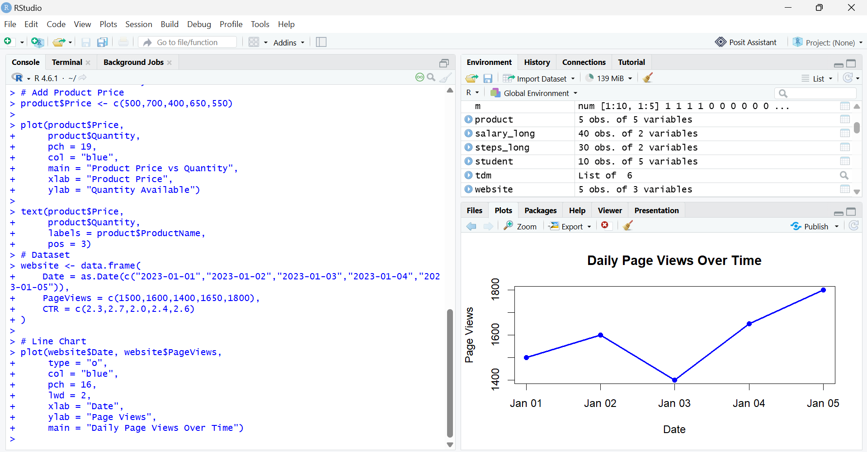

Question 2: Bar Chart (Top 3 Days with Highest CTR)
Code:
website <- data.frame(
Date = as.Date(c("2023-01-01","2023-01-02","2023-01-03","2023-01-04","2023-01-05")),
PageViews = c(1500,1600,1400,1650,1800),
CTR = c(2.3,2.7,2.0,2.4,2.6))
top <- website[order(-website$CTR), ][1:3, ]
barplot(top$CTR,
names.arg = top$Date,
col = "orange",
xlab = "Date",
ylab = "Click-through Rate (%)",
main = "Top 3 Days with Highest CTR")
Output:
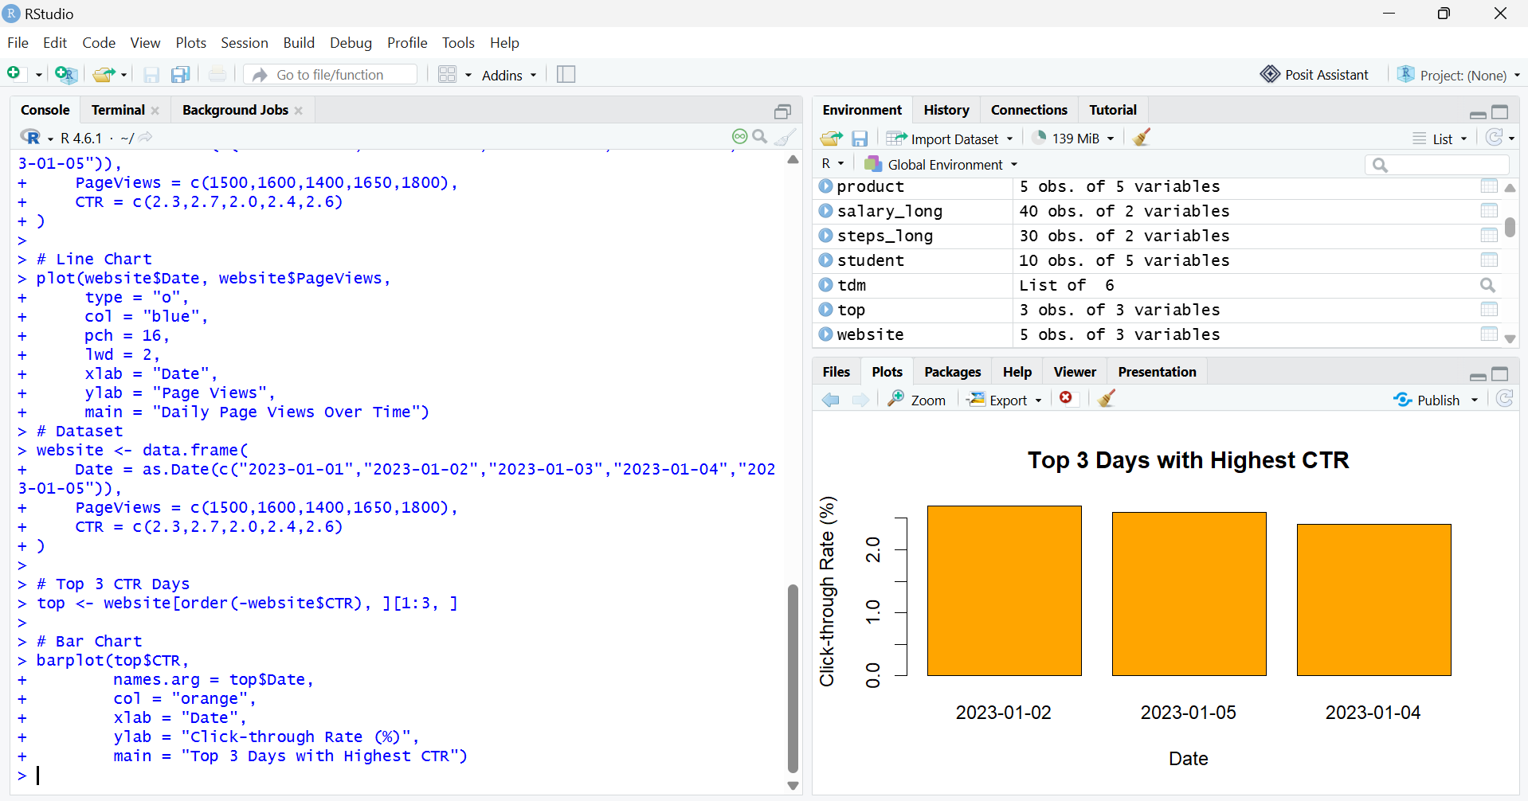

Question 3: Stacked Area Chart (Likes, Shares, Comments)
Code:
date <- as.Date(c("2023-01-01","2023-01-02","2023-01-03","2023-01-04","2023-01-05"))
likes <- c(300,350,280,370,400)
shares <- c(120,150,100,140,160)
comments <- c(80,90,70,85,95)
library(plotrix)
stackpoly(date,
cbind(likes, shares, comments),
col = c("skyblue","lightgreen","pink"),
xlab = "Date",
ylab = "User Interactions",
main = "Stacked Area Chart")
legend("topleft",
legend = c("Likes","Shares","Comments"),
fill = c("skyblue","lightgreen","pink"))
Output:
